**DAV HZL SR. SEC. SCHOOL, DARIBA**

**TENTATIVE CO-CURRICULAR ACTIVITIES 2024-25**

|  |  |  |
| --- | --- | --- |
| **Date** | **Class** | **Activity (Events)** |
| 06/04/2024 | III TO V | Cinematic Odyssey: Arya Samaj Chronicles |
| VI TO VIII | Narrative Alchemy: Crafting English Tales |
| IX TO XII | Lens Enchantment: Interclass Cinematic Journey |
| 20/04/2024 | III TO V | Soliloquy Symphony: Mastering English Monologues |
| VI TO VIII | Dramatic Flourish: Theatrical Skits in English |
| IX TO XII | Electoral Insights: Interclass PowerPoint Showdown |
| 04/05/2024 | III TO V | Artistry Unleashed: Collage Creation Extravaganza |
| VI TO VIII | Sculpting Stories: From Clay to Chronicle |
| IX TO XI | Pixel Perfection: Design Delights with Photoshop |
| 05/07/2024 | III TO VIII | Green Horizon: Plantation Expedition |
| 06/07/2024 | III TO V | Calligraphy |
| VI TO X | Echoes of Ecology: English Environmental Orations |
| 11/07/2024 | III TO XII | Leadership Unveiled: Investiture Spectacular |
| 20/07/2024 | III TO V | Lexical Showdown: Spellbinding Spell Bee |
| VI TO VII | Verbal Voyage: Vocabulary Ventures |
| IX TO XI | Enlightening Discourse: TED Talk Showdown |
| 03/08/2024 | III TO V | Culinary Chronicles: Fireside Cooking & Artistry |
| VI TO IX | Taste Temptations: Culinary Competition |
| 17/08/2024 | III TO VIII | Cultural Kaleidoscope: Rangoli, Rakhi& Arya Samaj Quizzes |
| 31/08/2024 | III TO V | Social Science Showdown: Quiz Quest |
| VII TO X | Parliamentary Prowess: Youth Debate Showdown |
| 06/09/2024 | III TO V | Hindi Heritage: Crafting Original Stories & Poems |
| VI TO VII | Hindi Heritage: Crafting Original Poems |
| VIII TO X | Declamatory Divinity: Hindi Oratory Odyssey |
| 05/10/2024 | III TO V | Blogosphere Brilliance: Crafting Digital Chronicles |
| VI TO VII | Wall Wonders: Mural Masterpieces |
| VIII | Wonders on earthen plates |
| 19/10/2024 | III TO V | Moral Mosaic: Hindi Skits on Values |
| VI TO IX | Theatrical Tribute: Great Personality Dramatizations |
| 08/11/2024 | III TO V | Melodic Medley: Songster Showdown |
| VI TO IX | Devotional Delights: Bhajan Bliss |
| 23/11/2024` | III TO V | Innovation Illuminated: Inventors' Showcase |
| VI TO VII | Journey of a Dreamer;Biography |
| VIII TO IX Sci. | Scientific Sorcery: Enchanting Science Magic |
| 07/12/2024 | III TO V | Literary Legacy: Bookmark Bonanza |
| VI TO VIII | Informative Imprints: Brochure Brilliance |
| 21/12/2024 | III TO IX | Math Marvels: Exploring Fun & Practical Mathematics |
| 18/01/2025 | III TO VII | Patriotic Penmanship: Slogan Sketching & Doodling |
| 31/01/2025 | III TO V | Resourceful Innovation: Waste Material Wonders & Presentations |

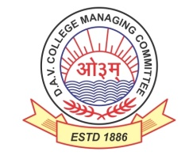

DAV HZL Sr. Sec. School dariba

rajsamand (raj.)

DAV HZL Sr. Sec. School dariba, rajsamand(raj.)

Split-up Syllabus

Class- III

Split-up Syllabus & Activities

for the session

2024-25

Class-V

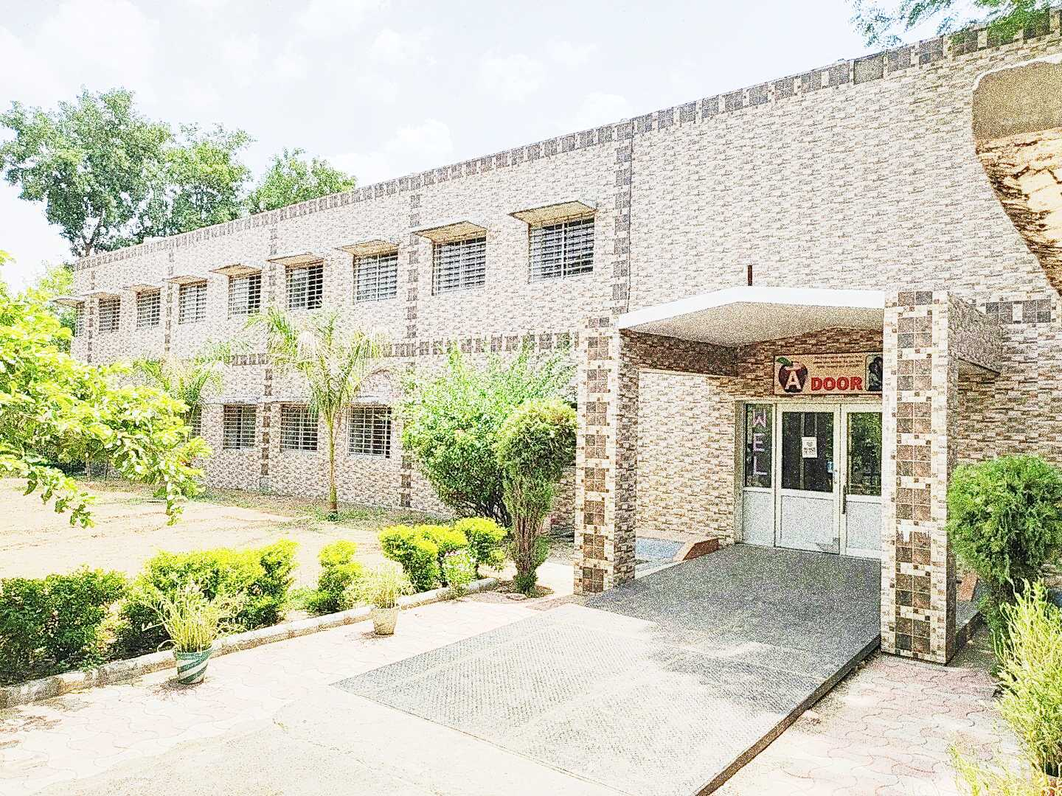

Address : Rajpura-Dariba, Distt. – Rajsamand (Raj.) 313211

Contact : (02952)265130 Email : davhzl_dariba@yahoo.com Website : www.davhzldariba.in

|  |  |  |
| --- | --- | --- |
| **Subject** | **PT- I** | **PT- II** |
| English | Reader –L- 1  Practice book- 1 | Reader –L- 2  Practice book- 2 |
| Hindi | भाषा माधुरी पाठ -1,2  भाषा अभ्यास पाठ 1,2 | भाषा माधुरी पाठ 3 व 5  भाषा अभ्यास पाठ 3 व 5 |
| Maths | L-1,2 | L-3,4 |
| Science | L-1, L-2 | L-3, L-4 |
| S.St. | L-1, L-2 | L-3, L-4 |
| laLÑr | पाठ 1 लिंगानि | पाठ 2,3 वचनम् |
| Computer Sc. | L-1 | L-2 |
| Moral Edu. | पाठ 1,2 | पाठ 3,4 |
| G. K. | Unit-1 | Unit -2 |

|  |  |
| --- | --- |
| **Subject** | **Mid Term** |
| English | Reader –Unit 1 L- Limites of mind Practice book- L -1 to 6 |
| Hindi | भाषा माधुरी व ,भाषा अभ्यास में पाठ 1 से 10  अपठित काव्यांश अपठित गद्यांश व्याकरण |
| Maths | L-1 to 6, 14 ,15 |
| Science | L-1, to L-6 |
| S. St. | L-1 to L-7 |
| laLÑr | पाठ 1से 7 लिंङ्गानि , वचनम् , लट्लकार धातुरूप , (भू , पठ् , गम् , वद्, ) संख्या 1 से 20 अव्यय, शब्द रूप ( राम, लता , फल , )  अपठित गद्यांश, चित्र वर्णनम् वाक्यानुवाद, पत्र लेखनम् |
| Computer Sc. | L-1 to L-4 |
| Moral Edu. | पाठ 1 से 7 |
| G. K. | Unit- 1,2,3 |
| Drawing | Page 2 to 20 |

|  |  |
| --- | --- |
| **Subject** | **PT- III** |
| English | Reader –L- Fearless Fighter  Practice book- L-7 |
| Hindi | भाषा माधुरी पाठ - 11, 12  भाषा अभ्यास पाठ 11 ,12 |
| Maths | L-10 & 11 |
| Science | L-7, L-8 |
| S.St. | L-8, L-9 |
| laLÑr | पाठ 8, 9 पुरुष लृटलकार ( भू , पठ् , गम् , वद्) |
| Computer Sc. | L-5 and 6 |
| Moral Edu. | पाठ- 8 से 9 |
| G. K. | Unit- 4 |

|  |  |
| --- | --- |
| **Subject** | **Final Term** |
| English | Reader –L- Fearless Fighter, Unit 4 and 5  Practice book- L 7 to 13 |
| Hindi | भाषा माधुरी व भाषा अभ्यास में पाठ 11 से 20  अपठित काव्यांश अपठित गद्यांश व्याकरण |
| Maths | L-4 ,7 to 13 & 16,17 |
| Science | L-7 to L- 12 |
| S.St. | L-8 to L- 13 |
| laLÑr | पाठ- 8 से 14 पुरुष, धातुरूप,लङ्लकार (भू , पठ् , गम् , वद्, ) सर्वनाम , शब्द रूप किम् ( त्रिषु fy³~xs'kq )शरीरस्य अङ्गानि संख्या 21 से 50  चित्र वर्णनम् ,अपठित गद्यांश, वाक्यानुवाद, पत्र लेखनम् |
| Computer Sc. | L-5 to 8 |
| Moral Edu. | पाठ- 8 से 13 आर्य समाज के नियम 1 से 6 |
| G. K. | Unit-4,5,6 |
| Drawing | Page no. 21 to 40 |

|  |  |
| --- | --- |
| **Exam** | **TENTATIVE DATES OF EXAM** |
| **PT – I** | First Week of May 2024 |
| **PT- II** | First Week of August 2024 |
| **MID – TERM** | Third Week of September 2024 |
| **PT – III** | Last week of November 2024 |
| **FINAL TERM** | Last Week of Feb.2025 |